
AMERICAN INTERNATIONAL UNIVERSITY-BANGLADESH (AIUB)
Faculty of Engineering
BAE 2101: Computer-Aided Design and Drafting
1.0 Title
Design a civil plan with electrical fitting & fixtures according to BNBC of a Multipurpose Restaurant Hall using AutoCAD.

2.0 Objectives
In this experiment, students will design the civil plan of a Multipurpose Restaurant Hall in AutoCAD with Electrical Fittings according to the Bangladesh National Building Code.

3.0 Experiment to Solve

The experiment should be designed by the students following below mentioned requirements:
1. | Draw a Civil Plan of a Multipurpose Restaurant Hall of total 6000 SFT+ Group Number*1000 (approx.) using AutoCAD Software. | [P1] | 20 points
2. | Draw the Fittings for the civil plan consist of necessary electrical fittings applying BNBC. | [P4] [P5] | 10 points

4.0 Lab Project Submission

. Course Name: | COMPUTER-AIDED DESIGN & DRAFTING | Course Code: | BAE 2101
Semester: | Spring 2023-2024 | Section: | L
Faculty: | MD. RAKIBUL ISLAM CHOWDHURY | OEL/Project | 1
Assessment: | OEL (CO2 & CO3), POI: P.e.1.C6
Submission Deadline: | 02/05/2024

Category | Unsatisfactory (1-5) | Below Average (6-10) | Good  (11-15) | Excellent  (16-20) | Secured Marks
Civil Plan | The civil plan is either copied or very poor with major errors. | The civil plan is below average or incomplete with major errors. | The civil plan is drawn partially as per requirement with minor errors | The civil plan is unique and drawn as per requirements with proper dimensions
Comments |  | Total Marks:

Category | Unsatisfactory (0-3) | Below Average (5) | Good  (7) | Excellent  (8-10) | Secured Marks
Electric Fittings | The fittings are incomplete or copied | The fittings are drawn or placed inappropriately without maintaining BNBC | The fittings are drawn and placed appropriately with partially complying to BNBC | The fittings are placed appropriately and maintaining BNBC
Comments |  | Total Marks:

Group - 2

SL # | ID | Student Name | Department | Marks
1 | 17-33226-1 | Md. Yusuf Ahmed | CSE
2 | 22-49157-3 | Khaza Tahmid Tahsin | CSE
3 | 22-49172-3 | Khan, Md. Sazzad | CSE
4 | 23-54469-3 | Kazi Mysha Rahman | CSE

Civil Plan of a Multipurpose Restaurant Hall of total of 8000 square Feet
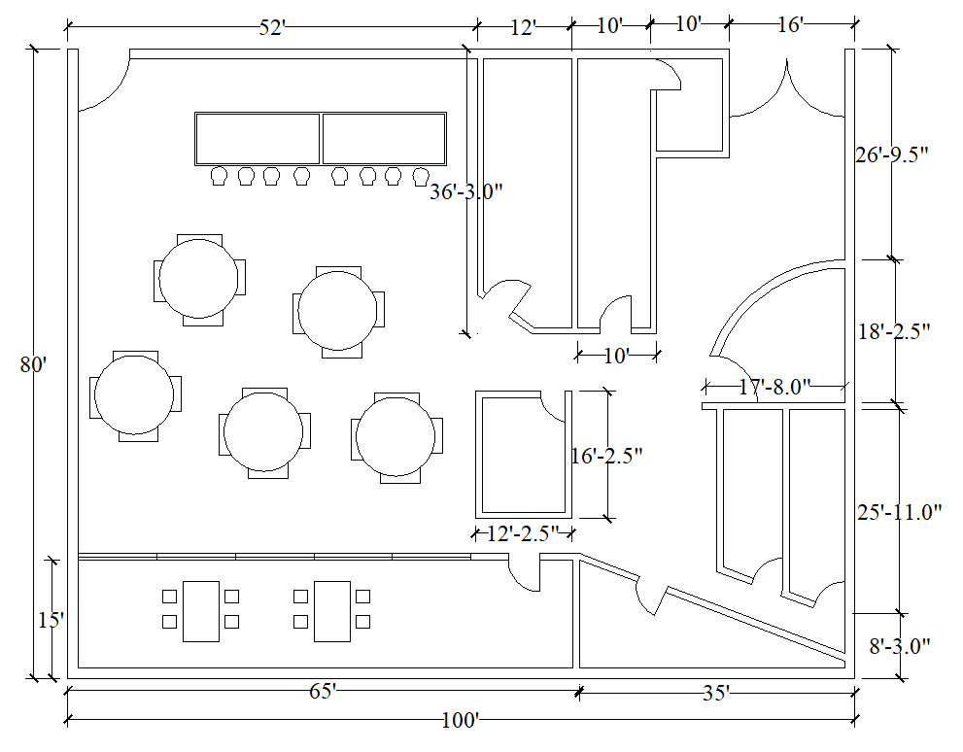
Electrical fittings of the Multipurpose Restaurant Hall

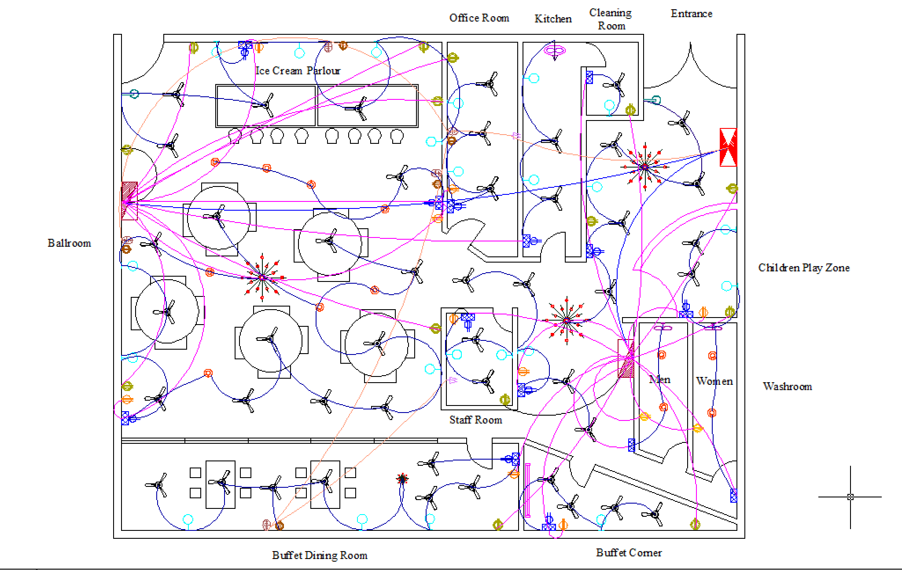

Light, Fan, AC Calculation:

Office Area : ( 36.25’ * 12’) = 435 Ft^2
General : 150 Lux….. 67 W
Self -Carrying Counters: 300 Lux …..135W
No of lights: 135/ 67 = 2
No of fan : 435/ 130 = 3.43 = 3
AC = 9.5 ton

Kitchen Area : ( 36.25’ * 10’) = 363 Ft^2
General : 150 Lux….. 56 W
Kitchens: 200 Lux …..75W
No of lights : 75/ 56 = 1.45 =2
No of fan : 363/ 130 = 2.8 = 3
AC = 9 ton

Cleaning Room Area : ( 14’ * 10’) = 140 Ft^2
General : 150 Lux….. 22 W
Cleaning : 200 Lux …..29W
No of lights : 29/ 22 = 1.32 =1
No of fan : 140/ 130 = 1.07 = 1
AC = 3.5 ton

Staff Room Area : ( 16.2’ * 12.2’) = 198 Ft^2
General : 150 Lux….. 30 W
Self-Carrying Counters : 300 Lux …..61W
No of lights : 61/ 30= 2
No of fan : 198/ 130 = 1.5= 2
AC = 5 ton

Buffet Area : ( 15.83’ * 35’) = 554 Ft^2
General : 150 Lux….. 85.5 W
Dining room: 150 Lux ….. 85.5W
No of lights : 2
No of fan : 554/ 130 = 4.3 = 4
AC = 16.5ton

Children play Room Area : ( 18.21’ * 117.67’) = 321 Ft^2
General : 150 Lux….. 49.7 W
Play zone: 300 Lux …..99.4W
No of lights : 2
No of fan : 2.47 = 2
AC = 8.5 ton

Washroom Area : ( 25.92’ * 8.67’) = 225 Ft^2
General : 150 Lux….. 34.83 W
Toilets : 100 Lux …..23.2W
No of lights : 4
No of exhaust fan : 2
AC = 1.5 ton

Single Dining Area : 962.5 Ft^2
General : 150 Lux….. 149.03W
Dining room: 150 Lux …..149.03
No of lights : 2
No of fan : 962.5/ 130
AC = 10 ton

Lobby Area : 4801.5 Ft^2
General : 150 Lux….. 743.37 W
No of lights : 17
No of fan : 26
AC = 21 ton

